OFFICIAL NOTIFICATION FOR
NON-ROUTINE OPERATIONS AND MAINTENANCE

NOTIFICATION DATE- 31 March 2010
PROJECT- The Dalles
RESPONSE DATE- No response required, but comments are always welcome.

Description of the problem- Battelle JSAT receiver are to be installed in The Dalles forebay by boat. Receiver clusters will be installed approx 150’ from dam in front of units F2, MU3, MU16 and MU20. Sluiceway intakes gate closures are required for safety. Battelle did not have the equipment available for install prior to Apr1 as originally planned. Sluiceway chain gate 5-2 requires crane support.

Type of outage required- Sluiceway intakes gates when boats in vicinity. Sluiceway will be in operation during entire installation, but without full 6 sluicegate opening per Fish Passage Plan. Sluiceway intake gates at unit 1 and 5 will be closed while boats are installing receivers at units F2 and MU3 on Apr6 ~0800-1200hrs. Sluiceway intake gate at unit 18 sluice will remain open on Apr6. Sluiceway intake gates at 18 will be closed while boats are installing receivers at units MU16 and MU20 on Apr7 ~0800-1200hrs. Maintenance will open chain gates 5-2 immediately after Battelle completes F2 and MU3 installations on Apr6. This overrides the previous plans of opening chain gates at 5-2 and 5-3 on Apr1 in previous coordination. Maintenance is unable to support unit 5 follow up chain gate closure on Apr 4 for Battelles boat work due to powerhouse workload.

Impact on facility operation- Sluiceway intake gate closures

Length of time for repairs- ~8hrs total over 2 days.

Expected impacts on fish passage- Expected passage per ’09 PSMFC sample numbers at John Day SMF are ~600yearling Chinook and 80 juv steelhead during first week of April. Extrapolating these estimates, approx 28 yearling Chinook and 3 juv steelhead would pass The Dalles during the 8hr planned sluiceway outage. Since the sluiceway would still be in operation. The expected impact to juvenile passage should be minimal. John Day SMF sampling starts Mar31. Not knowing 2010 present passage numbers, passage impact is uncertain.

Comments from agencies- no comments received.

Final results- The activity will occur as described above.

Tammy Mackey
NWP Operations Division Fishery Section
Columbia River Coordination Biologist
541-374-4552 Bonneville Office
503-961-5733 Blackberry
Tammy.m.mackey@usace.army.mil

J, K, L, M
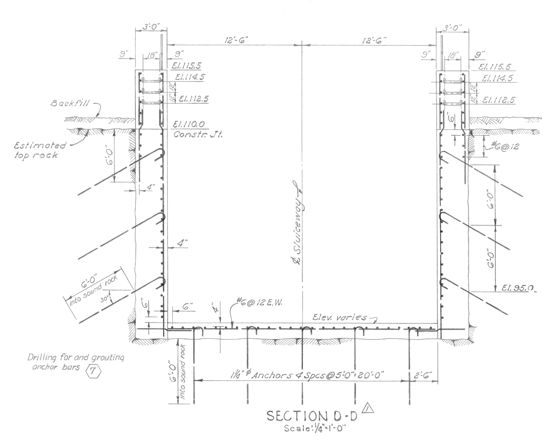

F
G
H
I
N
B,C,D,E
F
J,K,L,M
El. 85
P/Q Contact Zone
Grout Zone 2
El. 80

Primary Grout Holes

Secondary Grout Holes

Date: 1/22/10
From: Bob Cordie, Project Biologist, The Dalles Dam

Re; Contingency plan for The Dalles east fishway, south channel operation in the Westrick park oil spill recovery efforts

With the transformer spill in Westrick Park at close proximity to the south fishway channel, an unknown quantity of oil may be in the substrate in the immediate area. To date, no oil sheen has been observed in the channel. Close monitoring continues. There is a possibility of oil migrating into the channel during fish passage season, several months after the spill recovery efforts. Therefore this contingency plan will be presented as an alternative operation to allow oil recovery efforts.

Increased fishway inspection observations will be conducted immediately after the east fishway is returned to service to catch any oil sheen. This will be done during optimal lighting conditions at the Westrick building bridge and the south entrance area. If oil sheen is noted, the project ECC will immediately be notified.

If it is determined the volume of oil needs to be contained, the following operation may be implemented pending approval from regional fish managers.
- Shut down Fish unit 1 and 2.
- Install isolation bulkheads between powerhouse and south channel. This includes auxiliary water conduit bulkhead and channel bulkhead.
- Install south entrance bulkheads to isolate channel from river.
- Crane setup and structural prep work must be completed prior to fish unit shut down.
- Open all west and east entrance weirs to full open.
- Return fish unit operation to half load and slowly increase while monitoring east and west entrance flows.
- Maintain this operation during oil recovery efforts.

Fish Passage Data
Blue bars are flow percent flow volume. Maroon bars are percent passage.

Potential flow and fish passage affect;
South entrance passage ranges from 10-25% depending on species. South entrance flow is approximately 40% of total. If south entrance is closed, the 40% flow will be added to east and west entrances. However due to potential added pressure on fishway grating on east and west, the full 40% may not be used.
With added flow to the east and west, it’s possible the 10-25% south passage may be distributed to east and west without added overall dam passage delay. University of Idaho telemetry would be needed to verify potential overall passage delay.

